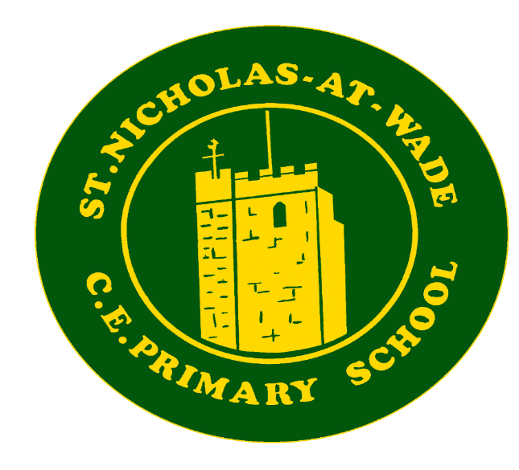
Music Development Plan
2025-26

Our Vision
At St Nicholas at Wade, music plays a significant role in every aspect of our lives and this belief is at the heart of our curriculum.

We aim to deliver a fun and engaging music curriculum, to inspire children to develop a love of music and their talent as musicians, and so increase their self-confidence, creativity and sense of achievement.

Music Provision Self-Assessment
Area | Category | Descriptor
Curriculum | Curriculum Design | The music curriculum is planned for in all year groups and skills are mapped progressively across Key Stages as guided by the National Curriculum.  Additional aspects (i.e. whole class music, Kent Teacher Year 4 Trumpet Lessons Weekly, 1-1 tuition and ensembles) are embedded into the planning of the music curriculum so that they support the musical outcomes.
Curriculum | Assessment | We use teacher assessment at planned points throughout the year using a variety of methods (video, audio, written etc.) to track pupil progress.  There are opportunities for self and peer assessment planned into all music lessons.
Curriculum | Timetabling | There is a dedicated curriculum music lesson on the school timetable each week for all year groups for a minimum of: KS1: 1 hour, KS2: 1hour.
Tuition and Ensembles | Instrumental and vocal tuition | Schools engage with an outside agency to provide 1-1 and small group tuition on up to 3 different instruments.  Up to 10% of the school population engage in instrumental tuition.
 | Instrumental Ensemble Provision | The school provides an opportunity for ensemble playing.  The ensemble (recorder) is regularly attended by a minimum of 5 pupils. The ensemble is led by a competent musician.
Singing | Singing Worship | There are termly opportunities for massed singing, Harvest, St Nicholas Cathedral Service, Christmas Carol Service, Easter, Leaver’s Service, Christmas/ Summer Fair.  There are weekly singing Worship (assemblies) for all pupils.  There is 1 or more weekly Worship for all pupils lead by a specialist. Singing is used frequently in music lessons to support curriculum learning.
Singing | Choirs | There is a school choir that rehearses weekly.  The school choir is led by either a competent member of staff who has expertise of leading a choir and practices healthy singing.
School life and opportunities | Leadership and  advocacy | There is a designated member of school staff, not a senior leader who has responsibility for music and advocates for the subject across the school  In collaboration with the designated music leader, senior leaders drive the development of music across the school and advocate for the importance of music in school life. There is a termly focus on different genres of music.  A named governor takes responsibility for monitoring music (arts) as part of the Curriculum; as a result, music is an integral part of daily school life.
School life and opportunities | Pupil Voice | Pupil voice is taken into consideration when planning internal school events through informal discussions.  Pupil voice is taken into consideration when planning for participation in external events either through informal discussion or student council.
School life and opportunities | Value of Music | Music is an important part of everyday life.  There is a yearly Music Recital to celebrate the musical talent of children in the school.
School life and opportunities | Inclusion | Schools signpost learners to KM bursary for 1-1 learning.  All music lessons are planned to use instruments/resources that are accessible and age appropriate to their students. All members of staff teaching music have an awareness of the pupil needs in the class.  Bespoke financial support is applied so that all pupils can access the curriculum and extra-curricular opportunities.  School provides access to alternative instruments where necessary.  Students have opportunities to listen to and interact with music from a wide range of cultures and traditions in all key stages including Western Classical Music, Popular Music (defined broadly) and Traditional Music from around the world.
School life and opportunities | Resources and equipment (physical) | There is a dedicated space for music within the school. This is equipped with a range of tuned and un-tuned instruments and technology is available for use. The school successfully integrates the use of Charanga teaching resources, including online resources, into its curriculum planning.
School life and opportunities | Budget | The budget (including Kent Music funding) is planned to support the delivery of the music curriculum and supports resourcing the school.
School life and opportunities | CPD | The lead member of staff sources bespoke CPD opportunities for the school to enable quality music provision to become embedded in school life.

Plan of Action
Area | Category | Actions  Meaningful tasks that contribute towards achieving the given objective | Deadline | KPIs/Evaluation Criteria  Ways of monitoring progress/ achieving your objective | RAG
School Life and Opportunities | Partnerships | - Invite performers into school  - Visit performances (Panto). | Incorporate opportunities throughout the year. | Liaise with Kent Music and Local secondary Schools
Curriculum | Timetabling | - Weekly music lesson. (Year 4 – Music Plus – Trumpet Lessons) | Kent Music - ongoing | All chdn have the opportunity in KS2 to play Recorder and Glockenspiel. Discuss Music Plus for the next cycle.
Curriculum | Curriculum design | Develop links with local Secondary Schools. | By Term 4 | Discuss with area Manager (Alan).

Review
Area | Category | Actions  Meaningful tasks that contribute towards achieving the given objective | Deadline | KPIs/Evaluation Criteria  Ways of monitoring progress/ achieving your objective | RAG

