Year 5 - Term 1
Homework
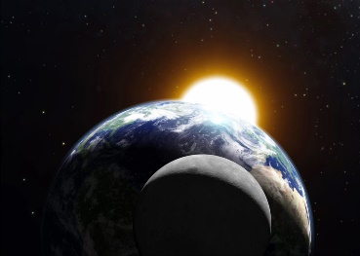
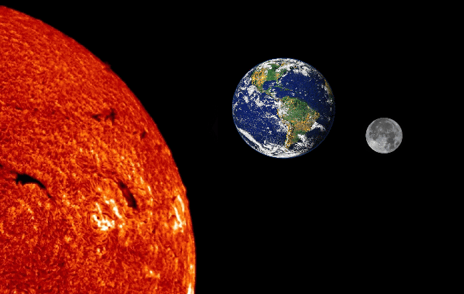

Our topic this term is:
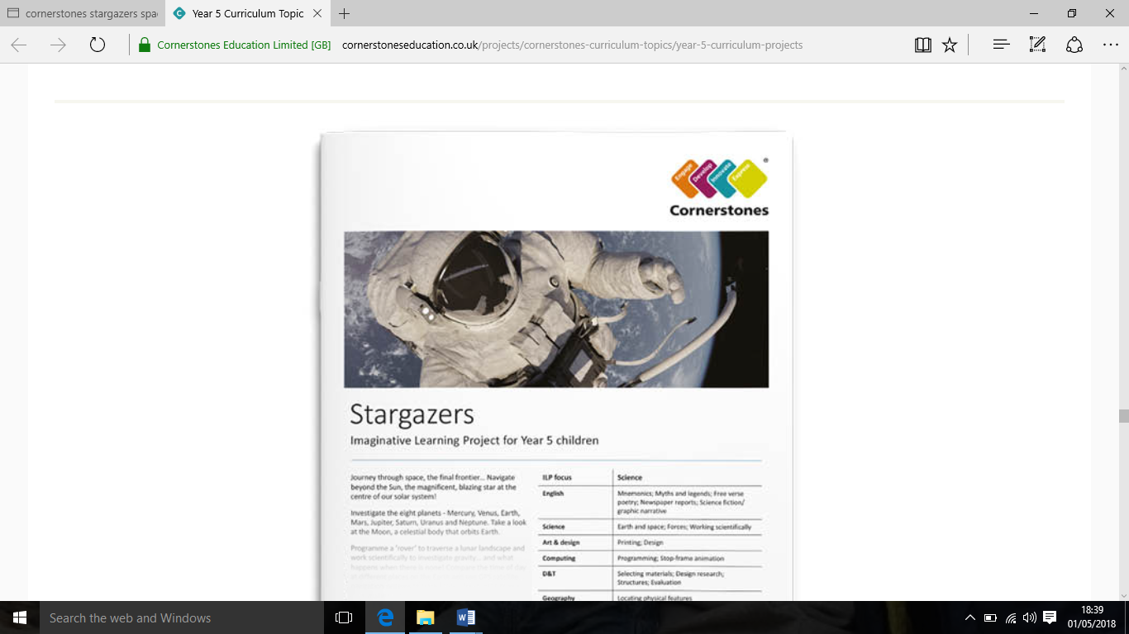
Stargazers

HOMEWORK
- Maths/SPaG: In Year 6, we set weekly maths and SPaG homework, which the children should complete in their homework folders.
- TTRS: Practise times tables ready for the Maths Rock Star Challenge.
- Reading: Children are expected to read for 30 minutes a day and complete quizzes on what they’ve read in school. Reading should be recorded in their homework diaries.
spelling
These are the spelling rules and patterns we will be focussing on this term.
Week 1: Challenge Words 1
Week 2: Challenge Words 2
Week 3: Challenge Words 3
Week 4: Challenge Words 4
Week 5: Challenge Words 5
Week 6: Challenge Words 6
Key Vocabulary
asteroid
astronaut
astronomy
black hole
comet
crater
gravity
ISS
Lunar
solar
Topic Homework
Here are some ideas for this terms homework, pick one (or more) or think of your own:
- Keep a moon diary for the course of a lunar month. Draw each stage of the moon every night and labelling each with the correct scientific name.
- Write a film review of a Star Wars film or write a space adventure of your own.
- Research how big the other planets are compared to Earth and the sun. Find a way to depict this.
- Design a pneumonic to remember the names and order of the planets.
- We will be painting our own version of Van Gogh’s ‘Starry Night’ – can you find any other pieces of art inspired by space.
- Design a rocket to blast off in to space or research how spaceships are made of and what astronauts took into space with them.

To be completed by: Last Monday of Term 1.

