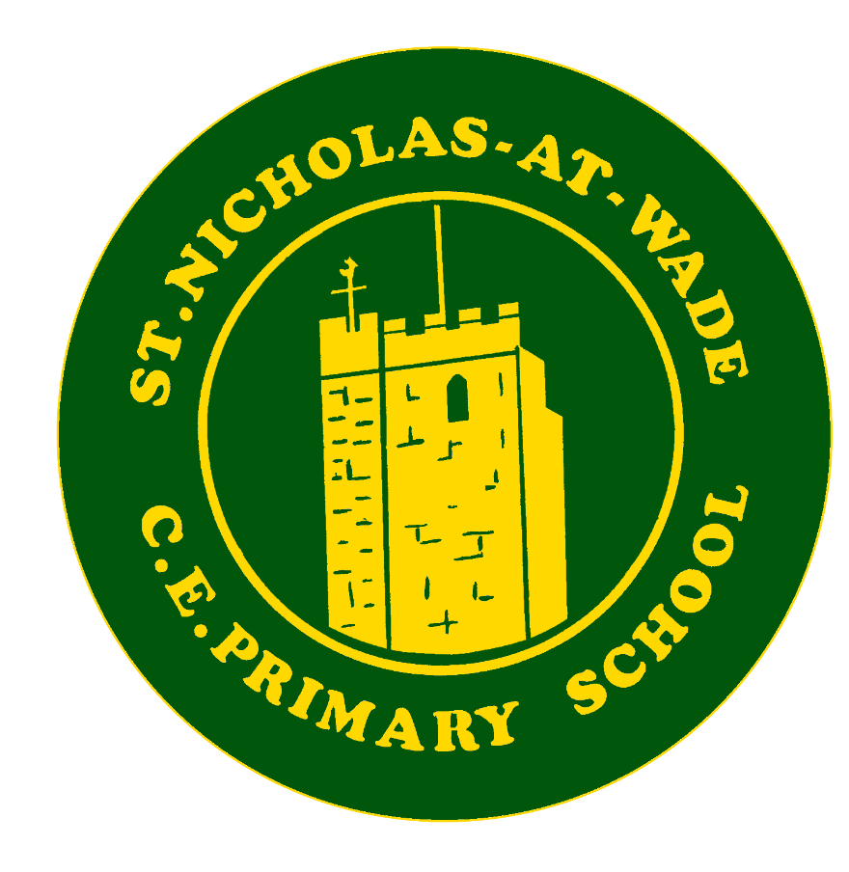

Curriculum - Oracy
Intent ♦ Implementation ♦ Impact
Intent
At St. Nicholas-at-Wade Primary School, we believe that all pupils deserve a fully rounded curriculum to become confident, independent, lifelong learners. Our curriculum intent is centred around the following drivers, which are fully embedded across all subjects:
- Every child a reader
- Every child a learner
- Every child a citizen
- Every child happy and healthy
- Every child creative and curious.

Intent
At St Nicholas at Wade, we recognise the vital role that Oracy plays in the holistic development of our pupils. Our intent is to foster a culture where spoken language is valued as a critical tool for learning, social interaction, and self-expression. We want to equip our children to be able to have the courage to speak out for themselves and for others, feeling confident in their ability to do this articulately, respectfully and with an open mind. We aim to ensure that:
- All pupils develop essential Oracy skills, including speaking, listening, and collaboration, which are crucial for their academic success and future employability.
- We provide an inclusive environment where every pupil feels empowered to express their thoughts and ideas fluently, irrespective of their background or prior linguistic abilities.
- Oracy is integrated across the curriculum, enhancing understanding and retention in all subjects, reinforcing the concept that speaking and listening are fundamental to learning.
- We foster self-confidence, courage and resilience in pupils, enabling them to articulate their thoughts clearly and engage in meaningful discussions.

Implementation
To realise our intent, we employ a comprehensive and strategic approach to the implementation of Oracy across the school, including:
- Structured Curriculum: Oracy is embedded into our curriculum through specially designed lessons that focus not only on phonics and vocabulary but also on turn-taking, questioning, and active listening techniques. We utilise models such as ‘Talk Partners’ and ‘Oracy Frameworks’ to structure discussions and collaborative learning. Every Lesson includes opportunities for high quality discourse and feedback and questioning from teachers stretches children’s responses and deepens thinking.
  - T4W (talk for writing) Curriculum. At the heart of T4W is oracy, children learn to ‘talk like the text’, this enables children to internalise the text, it’s structures and features in order to support writing. They have opportunities to orally rehearse what they will write.
- Variety of Contexts: We provide a range of contexts in which pupils can practise their Oracy skills, including class debates, storytelling sessions, presentations, and drama. These opportunities encourage pupils to engage with different forms of communication, from formal to informal.
- Public speaking: We provide as many opportunities as possible for children to practise speaking publicly. Some examples are:
  - Head pupils and prefects attending open days, leading on worship and filming the school tour and various other roles in school life
  - House Captains leading sports day, gathering house points and announcing scores weekly
  - JLT (Junior Leadership Team) school direction, class feedback, meeting with SLT
  - Christian Ambassadors, Leading service at church, participating in worship
  - Reading influencers. Interviewing for the Reading rocket and selling to the public. Meeting with English lead to decide school events and initiatives. leading key assemblies, recommending books and supporting younger children to read
  - Eco ambassadors. Leading assemblies and working with a range of adults at Monkton nature reserve
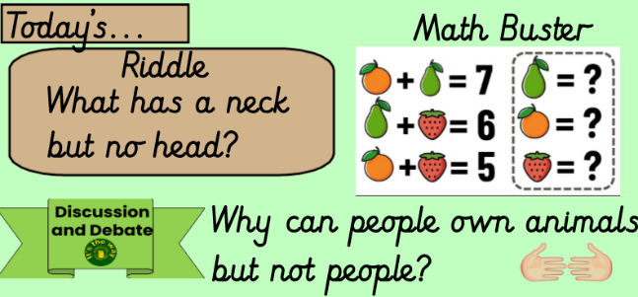
- Lunchtimes: We see lunchtime as an opportunity to strengthen children’s oracy, by encouraging purposeful discussions. Year 6 children head each table so that our youngest children are supported and the teacher on duty will take feedback. Each table has a frame on with discussion openers to scaffold children’s responses and encourage respectful debate.

- Discussion and debate: Research shows that children, engaging in two way dialogue that goes back and forth develops and enriches language. We promote this by providing opportunities across the curriculum to engage in discussion and debate. To Scaffold the children’s growing skills in this area, our oracy progression includes language stems.
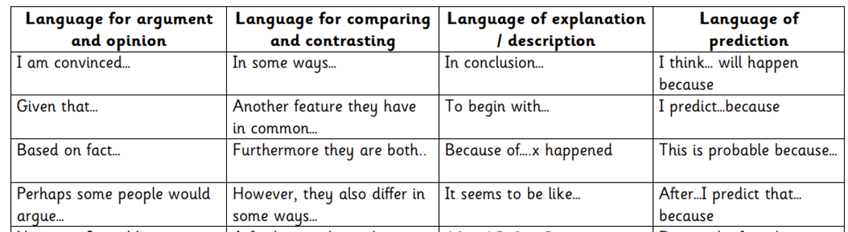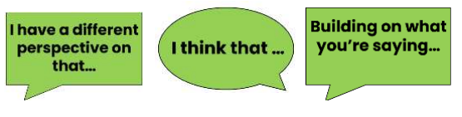

- Assessment and Feedback: We actively assess Oracy through formative assessments, peer assessments, and self-reflection. Feedback is given in real-time to support progress.
- Parental Involvement: We engage parents and the wider community by organising workshops and events that promote Oracy at home. This collaboration enhances the learning environment and builds a supportive network that values spoken language.
- Professional Development: Staff training with continuous professional development sessions focusing on best practices for teaching Oracy. This includes modelling effective Oracy strategies and using feedback to develop teaching practices further.

Impact
The impact of our Oracy education is evidenced by:
•Enhanced Communication Skills: Pupils demonstrate improved communication skills, engaging confidently in discussions and presentations, as well as showing significant growth in their ability to articulate ideas coherently.
•Academic Achievement: Data collected indicates a positive correlation between Oracy activities and academic performance, with pupils exhibiting improved outcomes in literacy and other curriculum areas.
•Increased Engagement: Observations reveal an increase in student engagement during lessons, with pupils actively participating and valuing their contributions to discussions, indicating a greater sense of ownership in their learning.
•Positive Behaviour and Relationships: Improved Oracy skills have led to better relationships among peers, with pupils demonstrating respect, understanding, and empathy during conversations, contributing to a harmonious learning environment.
•Ready for Future Challenges: Our pupils are well-prepared for future educational challenges, exhibiting confidence and competence in their spoken communication, which is crucial for their transition to secondary education and beyond.
By embedding Oracy into every aspect of school life, we nurture effective communicators who are equipped with the skills necessary to thrive both socially and academically, truly reflecting the ethos of an outstanding school.

