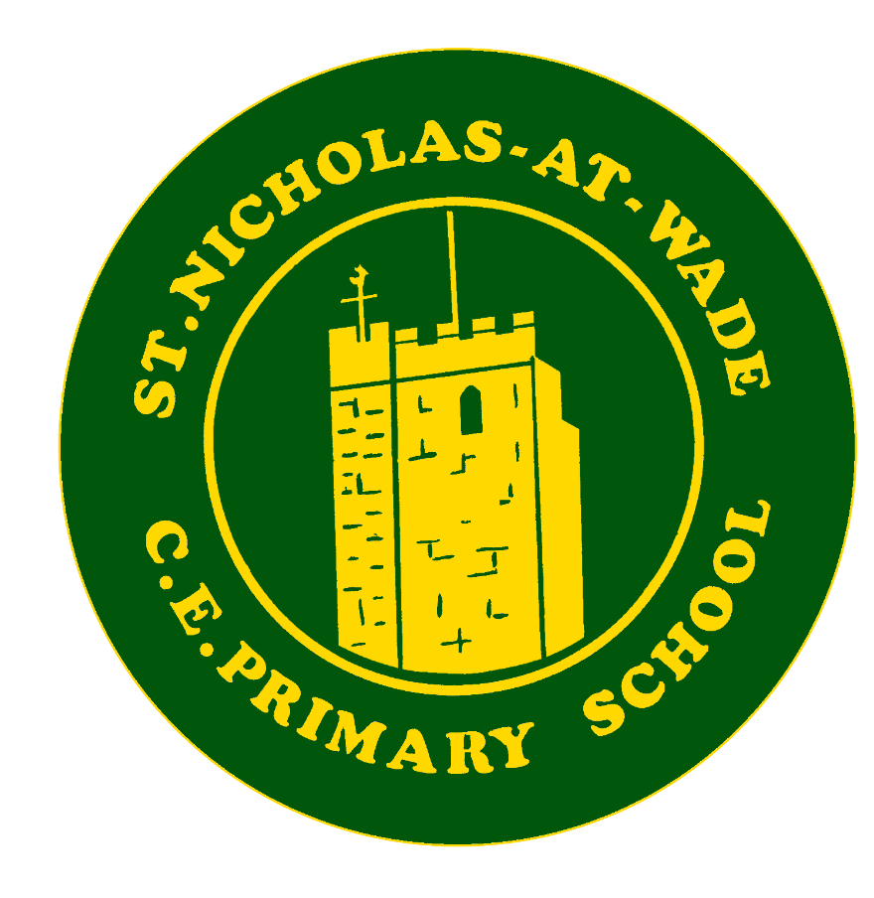
Curriculum – English - Oracy
Knowledge and Skills

Knowledge and Skills progression in ORACY Year group overview

Features
At key stage 1, the knowledge progression takes full account of the national curriculum’s strands of: Speech and language, reading, writing and spelling, vocabulary, grammar & punctuation

At key stage 2, the knowledge progression takes full account of the national curriculum’s strands of: Speech and language, reading, writing and spelling, vocabulary, grammar & punctuation

Skills are dependent on specific knowledge. A skill is the capacity to perform and in order to perform a deep body of knowledge needs to be acquired and retained.
The working scientifically part does not conform with the knowledge-rich system as it is checking on pupils’ ability to, amongst other things, carry out research, ask questions and carry out tests. The working scientifically statements should be assessed as an on-going feature of the science lessons, whilst the scientific knowledge should be assessed away from the point of teaching.

St Nicholas ENGLISH Experience
In addition to the National Curriculum knowledge and skills, at St.Nicholas at Wade Primary School, we want to enrich the curriculum with additional experiences within our locality. These additional experiences will include:
- Making regular use of the school library weekly, including teacher-led activities within this time.
- Regular support and updates from the student cohort - Reading Influencers.
- Visits from authors, poets, illustrators, publishers or book shops.
- Taking part in World Book Day.
- Taking part in termly Reading Challenges to encourage participation during holiday times.
- Participation in regular opportunities/competitions in writing narratives and poetry.
- Participation in a reward scheme to encourage participation in reading.
- Online reading log to encourage the home/school relationship and to promote engagement of reading by and within the family.
- Regular activities at our village church including a Christmas Nativity, Easter services etc
- The annual Year 6 production.
- Visitors in school - asking questions and participating in discussions.
- Lunchtime conversation starters.
- The Reading Rocket – participation in the creation of the Reading Influencer’s newsletter – interviews, fund-raising opportunities etc.
- Talk For Writing oral rehearsal of the model text.

Early Learning Goals feeding into National Curriculum – Communication and Language
The development of children’s spoken language underpins all seven areas of learning and development. Children’s back-and-forth interactions from an early age form the foundations for language and cognitive development. The number and quality of the conversations they have with adults and peers throughout the day in a language-rich environment is crucial. By commenting on what children are interested in or doing, and echoing back what they say with new vocabulary added, practitioners will build children's language effectively. Reading frequently to children, and engaging them actively in stories, non-fiction, rhymes and poems, and then providing them with extensive opportunities to use and embed new words in a range of contexts, will give children the opportunity to thrive. Through conversation, story-telling and role play, where children share their ideas with support and modelling from their teacher, and sensitive questioning that invites them to elaborate, children become comfortable using a rich range of vocabulary and language structures.
Communication and Language
ELG: Listening, Attention and Understanding
• Listen attentively and respond to what they hear with relevant questions, comments and actions when being read to and during whole class discussions and small group
interactions;
• Make comments about what they have heard and ask questions to clarify their understanding;
• Hold conversation when engaged in back-and-forth exchanges with their teacher and peers.
ELG: Speaking
• Participate in small group, class and one-to-one discussions, offering their own ideas, using recently introduced vocabulary;
• Offer explanations for why things might happen, making use of recently introduced vocabulary from stories, non-fiction, rhymes and poems when
appropriate;
• Express their ideas and feelings about their experiences using full sentences, including use of past, present and future tenses and making use of conjunctions, with
modelling and support from their teacher.

National Curriculum Subject Content
ORACY - Skills Progression
Spoken language | Year 1 | Year 2 | Year 3 | Year 4 | Year 5 | Year 6
Spoken language | (statutory)  Children learn to:  • listen and respond appropriately to adults and their peers  • ask relevant questions to extend their understanding and knowledge  • use relevant strategies to build their vocabulary  • give well-structured descriptions, explanations and narratives for different purposes, including for expressing feelings  • maintain attention and participate actively in collaborative conversations, staying on topic and initiating and responding to comments  • use spoken language to develop understanding through speculating, hypothesising, imagining and exploring ideas  • speak audibly and fluently with an increasing command of Standard English  • participate in discussions, presentations, performances, role play/improvisations and debates  • gain, maintain and monitor the interest of the listener(s)  • consider and evaluate different viewpoints, attending to and building on the contributions of others  • select and use appropriate registers for effective communication  • children build on the oral skills that have been taught in preceding years  (Non-Statutory)  • Children develop their competence in spoken language and listening to enhance the effectiveness of their communication across a range of contexts and to a range of audiences. They should therefore have opportunities to work in groups of different sizes – in pairs, small groups, large groups and as a whole class. Pupils should understand how to take turns and when and how to participate constructively in conversations and debates.  • Children develop their vocabulary, ranging from describing their immediate world and feelings to developing a broader, deeper and richer vocabulary to discuss abstract concepts and a wider range of topics, and enhancing their knowledge about language as a whole.  • Children receive constructive feedback on their spoken language and listening, not only to improve their knowledge and skills but also to establish secure foundations for effective spoken language in their studies at primary school, helping them to achieve in secondary education and beyond.

