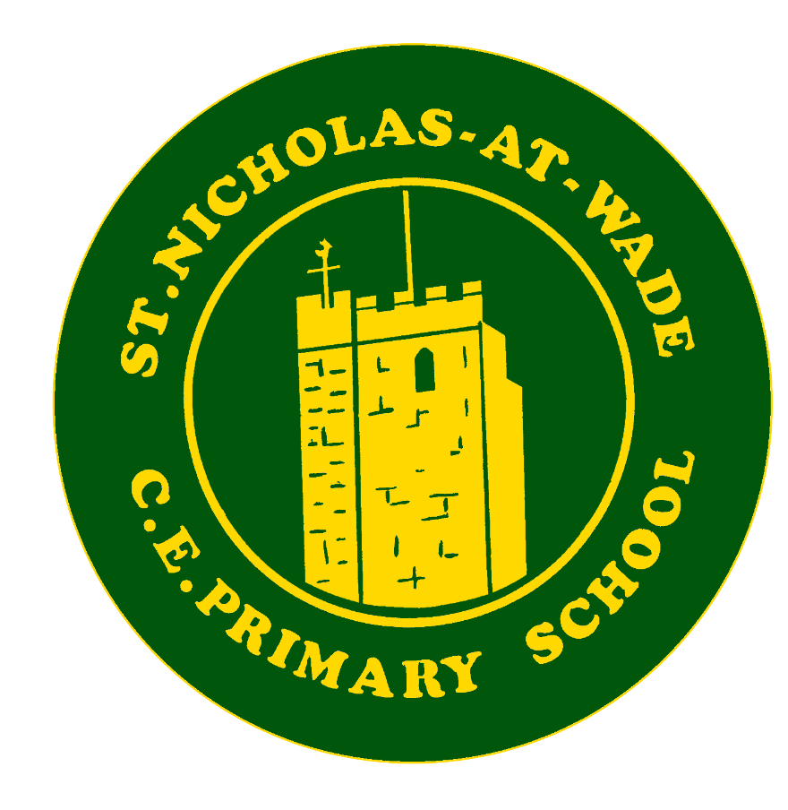

Curriculum – English
Knowledge and Skills

Knowledge and Skills Progression – ENGLISH - Reading
EYFS: Literacy: Comprehension, Word Reading and Writing
Early Literacy skills provide children with the firm foundations needed for success in school and life. Through storytelling, singing, role play, mark making, writing and group discussions, children will be able to make sense of the world around them. As well as exposing the children to language rich texts, including fiction, non-fiction and poetry, the children also take part in a well-developed, synthetic phonics programme (Little Wandle) where they revisit, learn and apply sounds to their reading and writing. Children are then able to apply and consolidate what they have learnt through open ended reading and writing opportunities. Our children will be able to:
• Demonstrate understanding of what has been read to them by retelling stories and narratives using their own words and recently introduced vocabulary.
• Anticipate, where appropriate, key events in stories.
• Use and understand recently introduced vocabulary during discussions about stories, non-fiction, rhymes and poems and during role-play.
• Say a sound for each letter in the alphabet and at least 10 diagraphs.
• Read words consistent with their phonic knowledge by sound-blending.
• Read aloud simple sentences and books that are consistent with their phonic knowledge, including some common exception words.
• Write recognisable letters, most of which are correctly formed.
• Spell words by identifying sounds in them and representing the sounds with a letter or letters
• Write simple phrases and sentences that can be read by others.
For a further breakdown of the Early Years, see the EYFS Progression document.
Content domains | Year 1 | Year 2 | Year 3 | Year 4 | Year 5 | Year 6
Word Reading  Decoding | • Little Wandle phonics.  • apply phonic knowledge to decode words  • speedily read all 40+ letters/groups for 40+ phonemes.  • read accurately by blending taught GPC •read common exception words. • read common suffixes (-s, -es, -ing, -ed, etc.)  • read multisyllable words containing taught GPCs.  • read contraction words and understand the use of the apostrophe represents the omitted letter.  • re-read books to build up their fluency and confidence.  By the end of Year 1 children will have completed Phase 5 and use their phonics to decode and blend unknown words. They should be encouraged to read known words automatically without blending. | • Little Wandle Phonics - Rapid Catch-up as required.  • decode unknown words applying phonic knowledge.  • recognise, read and identify the full range of vowel graphemes.  • recognise, read and identify the full range of consonant graphemes.  • break words into two or more syllables.  • read further common exception words.  • recognise and read a range of suffixes and use these to construct the meanings of words in context e.g. ed, ing, er,est, ly, ful, less, ness, ment.  By the end of Year 2 children read most words automatically, reading 90 words per minute of an age-appropriate text, mostly accurately. | • Little Wandle Phonics. Rapid Catch-up as required.  • decode unknown words rapidly and without undue hesitation.  • recognise, read and identify the full range of vowel graphemes.  • recognise, read and identify the full range of consonant graphemes.  • break words into syllables.  • recognise and read a range of prefixes and use these to construct the meaning of words in context e.g. re…, de…, pre…, non…, mis…, ex…, co…, anti… g.  • recognise and read a range of suffixes and use these to construct the meaning of words in context e.g. …tion, …ive, …ic i.  • use the context of the sentence to help read unfamiliar words.  By the end of Year 3 children will be able to read accurately at a speed sufficient for them to be able to focus on their understanding. They should be able to decode most new words outside their spoken vocabulary. | • Little Wandle Phonics. Rapid Catch-up  • as for Y3.  • use a range of strategies to decode unfamiliar words.  • read and understand the meaning of words with prefixes from the Year 3/4 curriculum.  • read and understand the meaning of words with suffixes from the Year 3/4 curriculum.  • give meaning to new language using the context in which it appears.  By the end of Year 4 children will become more independent, fluent and enthusiastic readers. They will be able to use their existing knowledge of known pronunciation to pronounce new words with increased accuracy. | • Little Wandle Phonics. Rapid Catch-up  • as for Y4.  • use a range of strategies to decode unfamiliar words without impacting on overall fluency.  • read and understand the meaning of words with prefixes from the Year 5/6 curriculum.  • read and understand the meaning of words with suffixes from the Year 5/6 curriculum.  • use knowledge of vocabulary and context to give meaning to new language.  By the end of Year 5 children will be choosing and reading age-appropriate interest-level texts. They will be able to read most words effortlessly and work out how to pronounce unfamiliar written words with increasing automaticity. Children become more confident to read aloud to an audience. | • Little Wandle Phonics. Rapid Catch-up  • as for Y5.  • use appropriate decoding strategies fluently and accurately.  • apply their growing knowledge of root words, prefixes and suffixes (morphology and etymology) to read aloud and to understand the meaning of new words  • read a wide range of exception words including the Year 5/6 curriculum list, which occur in the texts they read.  By the end of Year 6 children will be reading a wide range of texts both in school and outside, for pleasure and information. Children build on their confidence to read aloud with increased intonation and fluency to engage the audience.
Fluency and automaticity | • speedily read all 40+ letters/groups for 40+ phonemes.  • read aloud phonically-decodable texts. | • read aloud with intonation that shows understanding.  • persevere with challenging texts (whole texts, including novels) to read with fluency, understanding and expression.  • read fluently at 100+ words per minute when reading unknown texts.  • recognise an increasing range of punctuation (. CL ! ? " " , ') and use this to add expression and understanding to the text. | • read 200 words at expected level in 5 minutes. • recognise an increasing range of punctuation (. CL ! ? " " , ') and use this to add expression and understanding to the text, including the apostrophe for omission. | • can read age-appropriate texts with a good level of fluency and stamina.  • uses a range of punctuation to add meaning to what they are reading. | • reads with fluency and stamina.  • explains how punctuation and sentence construction is used to enhance meaning.  • perseveres with challenging texts. | • read aloud with intonation that shows understanding.  • persevere with challenging texts (whole texts, including novels) to read with fluency, understanding and expression.
Child as a Reader / Reading for Pleasure | • listening to and discussing a wide range of poems, stories and non-fiction at a level beyond that at which they can read independently • being encouraged to link what they read or hear read to their own experiences. • becoming very familiar with key stories, fairy stories and traditional tales, retelling them and considering their particular characteristics. • recognising and joining in with predictable phrases. • learning to appreciate rhymes and poems, and to recite some by heart. • drawing on what they already know or on background information and vocabulary provided by the teacher. • checking that the text makes sense to them as they read and correcting inaccurate reading. | • developing pleasure in reading. • participate in discussion about both books that are read to them and those they read for themselves. • increasingly familiar with a wide range of stories, fairy stories and traditional tales. • recognise recurring literary language in poems and stories. • make links between the book they are reading and other books they have read. • read for pleasure and is developing reading preferences. | • increasing familiarity with a wide range of books (including fairy stories, myths and legends) and retelling some of these orally.  • read for enjoyment and chooses to read (can absorb themselves in a book/text).  • recognise some different forms of poetry (for example, free verse, narrative poetry).  • read books that are structured in different ways and comment on their structures.  • read for a range of purposes.  • use a dictionary to check the meaning of words they have read. | • discuss a range of books and texts that they have read, explaining key information and giving their opinion about it. • is familiar with different types of poetry.  • recognises similarities and differences between texts structured in different ways.  • uses reading as a tool to support other aspects of learning.  • understands when it would be helpful to use a dictionary to support reading. | • gives developed detail in discussion about a range of texts, including personal opinion.  • explain different reasons for reading, including for enjoyment.  • read and discuss the construction and meaning of different types of poetry.  • compare and evaluate different texts against their intended purpose. | • skim texts to get the general idea of the content of a piece.  • scan texts to find particular information.  • construct visual images.  • compare, contrast and evaluate different texts.  • talk about the types of texts they enjoy and that interest them.
Retrieval | • answer a question about what has just happened in a story. • develop their knowledge of retrieval through images • answer a question about what has just happened in a story - who, what, where, when, which, and how questions. • develop their knowledge of retrieval through images. | • recall main points with reference to the text (who, what, where, when, how, why answers). • read closely to obtain specific information e.g. what type of clothes someone was wearing. • identify, select and highlight key words in a sentence to answer recall questions. • begin to scan for a specific purpose e.g. looking for specific information e.g. names of characters. • recognise and talk about the main differences between fiction and non-fiction texts. | • show understanding of main points with reference to the text (who, what, where, when, how, why). • read closely to obtain specific information e.g. what type of clothes someone was wearing. • identify, select and highlight key words in a sentence to answer recall questions.  • begin to scan for a specific purpose e.g. looking for specific information: names of characters etc.  • begin to skim e.g. to search for adjectives which describe a character.  •check the accuracy of what they are retrieving by reading around the words or phrases they find.  • recognise and talk about the main differences between fiction and non-fiction texts.  • identify the key features of different text types.  • understand and talk about the purpose of a specific paragraph e.g. it groups information together about…  • understand and talk about the features of page layout in non-fiction texts e.g. titles, subheadings, labels, diagrams and charts. | • understand and explain the main points from what they have read, with direct reference to the text. • identify explicit details from the text, showing the section of the text they found the information. • is able to skim short passages to answer recall questions. • is able to scan short passages to answer recall questions.  • talk about key differences between text types, including texts of the same type but written by different authors. • is able to explain how paragraphs have been used to organise a text.  • is able to explain how the format and presentation of a text impacts on the reader.  • retrieve and record information from non-fiction.  •extract information and make notes. | • retrieve key details and some quotations from the text to demonstrate understanding of key details/information in a text.  • identify explicit details from the text, showing exactly where in the text they found the information.  • is able to skim and scan whole texts to answer recall questions.  • identify the text type according to key features.  • recognise common themes/styles in texts written by the same author.  • comment on the impact of organisational and presentational features of a text.  • retrieve, record and present information from non-fiction.  •extract information and make notes using quotations and reference to the text. | • retrieve key details and quotations to demonstrate understanding of character, events and information.  • answer who, what, why, where when, which, how questions, using direct reference to and quotes from the text.  • provide developed explanations for key information, events, character actions and motivations.  • provide straightforward explanations for the purpose of the language, structure and presentation of texts.  • identify whether statements from a text are fact or opinion.  • decide whether statements about a text are true or false, using direct reference to the text.  • retrieve, record and present information from non-fiction.  •extract information by skimming and scanning and make well organised notes using quotation and reference to the text using own words..
Language and Vocabulary | • discuss word meanings, linking new meanings to those already known. • draw upon knowledge of vocabulary in order to understand the text. • join in with predictable phrases. • use vocabulary given by the teacher. • discuss his/her favourite words and phrases. • read aloud their own writing to their peers and the teacher. | • discuss word meanings, linking new meanings to those they already know. • recognise adjectives, adverbs and similes. • identify how vocabulary choices effect meaning. • use the context of the text to help read unfamiliar words. • recognise simple recurring literary language in stories and poetry. • read aloud their own writing with appropriate intonation to make the meaning clear. | • discuss word meanings, linking new meanings to those they already know. • recognise adjectives, adverbs/simple adverbial phrases and similes. • identify how vocabulary choices affect meaning e.g. 'Crept lets you know that he is trying to be quiet but also that he was going slowly because he did not want to be caught.' • comment on the author's choice of language to create mood and build suspense e.g. suddenly is used to show that something surprising is coming next. • collect words from their reading to use in their own writing.  • explain how simple and complex sentences influence meaning.  • read aloud their own writing with appropriate intonation, and controlling volume and tone to make the meaning clear. • use dictionaries to  Check the meaning of words they have read | • discuss word meanings, based on their existing vocabulary knowledge.  • identify descriptive devices within a text i.e. expanded noun phrases, adverbial phrases, similes etc. • explain how vocabulary choices affect meaning in a range of text types. • identify language used to create atmosphere and discuss why this language has been chosen.  • Use new language from their own reading experiences in their written and spoken work.  • discuss how the use of different sentence types changes the meaning of a passage.  • read aloud their own writing with appropriate intonation, and controlling volume and tone to make the meaning clear.  • use dictionaries to  check the meaning of words they have read | • explain clearly how vocabulary choices affect meaning in a range of text types.  • recognise a range of descriptive devices including figurative language.  • comment upon language choices/structures of different authors.  • confidently use new language from their own reading experiences in their written and spoken work.  • explain the use of sentence structures according to desired effect on the reader.  • perform their own writing with appropriate intonation, volume and movement so that meaning is clear.  • use dictionaries and thesaurus to check the meaning of words they have read | • show an understanding of the meaning of vocabulary in different contexts.  • find and copy one word/groups of words with a particular meaning.  • find words in a text that most closely match the meaning of a given word.  • identify how language. Structure and presentation contribute to meaning.  • identify a range of figurative language e.g. metaphor, simile, alliteration, idioms, euphemism, personification etc. and comment on its effect on the reader.  • understand and recognise different forms of poetry, discuss their meaning and impact on the reader.  • perform their own writing with appropriate intonation, volume and movement so that meaning is clear.  • use dictionaries and thesaurus to  Check the meaning of words they have read
Inference | • children make basic inferences about characters’ feelings by using what they say as evidence. • infer basic points with direct reference to the pictures and words in the text. • discuss the significance of the title and events. • demonstrate simple inference from the text based on what is said and done. | • discuss the actions of characters and justify views on the basis of what is being said and done. • summarise the main points from a passage or a text. • ask questions to improve their understanding of a text. • explain what the writer might be thinking Is beginning to identify the author’s main purpose for writing. | • discuss the actions of the main characters and justify views using evidence from the text. • make inferences about characters' actions in a story based upon evidence from the text. • identify and discuss characters. speculating how they might behave and giving reasons linked to the text. • empathise with a character's motives and behaviour. • identify the language used to create mood. | • is able to describe the actions of characters in a text and begin to explain them, in the context of the narrative. • make inferences about characters' actions in a story based on evidence from the text. • empathise with a character's motives and behaviours.  • infer underlying themes and ideas. | • explain isolated events from a text, in the context of the whole narrative.  • prove or disprove simple statements about a character by finding evidence in a text. • begin to use evidence from description, dialogue and action to support their ideas. • empathise with a character's motives and behaviours.  • make links between the author’s use of language and the inferences drawn. | • search for simple clues within the text to support reading ‘between the lines.’  • make developed inferences drawing on evidence from the text and wider personal experience.  • use clues from action, dialogue and description to interpret meaning.  • prove or disprove a statement about character or setting by finding evidence in the text.  • explain and justify inferences, providing evidence from the text to support reasoning.  • empathise with different characters' points of view.
Sequencing and Summarising | • retell familiar stories orally e.g fairy stories and traditional tales. • recall the main points of a narrative in the correct sequence. | • Identify components of a story - beginning, middle and end. • retell a story clearly and with appropriate detail. • discuss the sequence of events in a text and how information is related. • identify or provide own synonyms for specific words within the text. | • summarise the main points from a passage or a short text. | • summarise the main details from more than one paragraph in a few sentences, using vocabulary from the text. | • summarise the main points from a whole text, identifying the key details that support the main ideas.  • check the book makes sense to them by discussing their understanding and exploring the meaning of words in context.  • distinguish between statements of fact and opinion and understand why this is important to interpreting the text. | • accurately and selectively summarise main ideas, events, and information from across the text or a range of sources and use quotes for illustration.  • use information from the whole text to answer questions.  • distinguish between statements of fact and opinion and recognise them in the language used by authors to influence readers.
Prediction | • predict what might happen on the basis of what has been read so far in terms of story, character and plot. • make simple predictions based on the story. • begin to explain these ideas verbally or though pictures. | • make predictions on basis of what has been read so far and on their own life experience. | • make plausible predictions based on details stated and implied in the text (or of books on similar themes or by the same author). | • make predictions based on details stated and implied in the text or similar reading experiences, giving clear reasons for their ideas. | • give feasible, reasoned predictions based on evidence. | • make developed predictions that are securely rooted in the text.  • explain their prediction choices fully, using evidence from the text.  • make predictions about characters including how their behaviour may/may not change and how they may/may not appeal to the reader, justifying answers with reference to the text.
Responding to the Text | • listen, share and discuss a wide range of high quality books (poetry /picture books / stories / information texts) which are beyond those they can read themselves. • participate in discussion about texts that are read to them and those they read to themselves, taking turns and listening to others. • draw links between the text and their own experiences. • discuss the significance of the title or events. • learn to appreciate poems and rhymes, beginning to express reasons for preferences. • begin to | • develop their pleasure in reading by listening to, discussing and expressing their views on a wide range of texts including contemporary and classic poetry, stories and non-fiction at a level beyond their independent reading ability. • participate in discussion about texts that are read to them and those they read to themselves, taking turns and listening to others. • discuss the sequence of events in stories and re-tell these orally. • recognise simple recurring literary language e.g. once, long, long ago: far, far away. •clarify the meaning of words, linking to know vocabulary. • discuss favourite words/phrases. | • listen to and discuss a wide range of fiction, poetry, plays, non-fiction and reference books or textbooks.  • begin to identify the author's main purpose for writing - 'He doesn't want any more turtles to be killed'.  • begin to identify main ideas drawn from more than one paragraph.  • explain how they think the author wants the reader to respond.  • explain what the writer might be thinking – ‘He thinks they are being mean’.  • begin to identify and comment on different points of view in the text.  • simply evaluate specific texts with reference to the text. | • listen to and discuss a wide range of fiction, poetry, plays, non-fiction and reference books or textbooks.  • identify the main purpose of a text.  • discusses ideas from throughout a text e.g. how a conclusion may be linked to an opening.  • identify intended impact of a text and explain whether they feel the text has had the desired effect.  • discuss viewpoints in a text where appropriate of more than one character.  • evaluate the overall quality of a text, as well as the inclusion of specific features.  • identify how language, paragraph, structure and layout contribute to meaning.  • with guidance, identify and discuss authorial choice and its effects. | • recommend books that they have read, giving reasons for their choices.  • explain texts structured in different ways for a range of purposes i.e. tables in non-fiction, flashbacks in narrative etc.  • select information from across a text to explain or illustrate their ideas.  • make accurate and appropriate comparisons within and across texts.  • with support, discuss and evaluate how authors use figurative language, talking readily about the effect on the reader.  • with guidance, distinguish between fact and opinion.  • provide reasoned justifications for their views. | • explain and discuss their understanding of what they have read, expressing their point of view and challenging others’ courteously.  • make accurate and appropriate comparisons within and across texts.  • discuss and evaluate how authors use language, talking readily about the effect on the reader.  • distinguish between fact and opinion.  • identify and discuss the use of figurative language and its impact.  • provide reasoned justifications for their views.
Themes & Conventions | • become familiar with key stories and traditional tales. • begin to appreciate rhymes and poems and to recite some by heart. • discuss the significance of the title and events. • become familiar with key stories and traditional tales, retelling them. • understand the difference between fiction and non-fiction. • understand the terms story, fairy story, rhyme, poem, cover, title, author. • become increasingly familiar with and retell a wide range of stories, fairy stories and traditional tales. Consider their particular characteristics. | • become increasingly familiar with and retell a wider range of stories, fairy stories and traditional tales, including those at a level beyond which they can read independently. • make comparisons between books, noting differences and similarities. • read non-fiction books that are structured in different ways. | • read books that are structured in different ways and show some awareness of the various purposes of reading.  • explore and discuss underlying themes and ideas.  • make simple connections between books by the same author eg ‘Dick King-Smith often writes about animals.’  • identify and name presentational devices in non-fiction.  • identify themes and conventions in a wide range of books e.g. the triumph of good over evil and magical devices in fairy stories.  • recognise some features of the text that relates to its historical setting or its social or cultural background e.g. 'The girls had on red flannel petticoats because that is what they wore then' or 'Grandpa Chatterji wears a dohti because he comes from India. | • identify themes and conventions in a wide range of books e.g. make relevant links to known texts and personal experience. e.g. bullying  • make links between texts and the wider world.  • identify how a range of presentational devices guide the reader in non-fiction.  • recognise some different forms of poetry e.g. free verse, concrete, acrostic  • begin to recognise the features that characterise books set in different cultures or historical settings. | • identify key themes and style in books and extracts by a range of authors.  • identify how presentational and organisational devices vary according to the form and purpose of the text.  • discuss and evaluate how authors use language, considering the impact on the reader.  • make simple links between texts, their audience, purpose, time and culture, drawing on knowledge of authors.  • recognise the features that characterise books set in different cultures or historical settings. | • identify /explain how the sequence of events in a narrative fiction contributes to meaning as a whole.  • find and discuss evidence of themes and conventions in different genres and forms of text.  • identify and comment on the grammatical features and genre-specific language features of texts. including authorial choice.  • identify key features such as setting, action, past events.  • identify and comment on the presentational features of texts.  • use text format and text features accurately to determine text type.  • explain and justify how texts relate to audience, purpose, time and culture and refer to specific aspects of a text that exemplify this.  • recognise texts that contain features from more than one genre or demonstrate shifts in formality.
Oracy and Reading | • start to engage in partner talk (TTYP) by turning to their partner and attempting to give own opinion including likes and dislikes. • link what they read or hear to their own experiences. • explain clearly their understanding of what has been read to them. • express views about events or character. | • increasingly, engage in partner talk (TTYP) by turning to their partner giving their opinion and attempt to listen to the opinion of others. • explain and discuss their understanding of books, poems and other material, both those that they listen to and those that they read for themselves. • express own views about a book or poem. • discuss some similarities between books. | • participate in discussion about both books that are read to them, and those they read for themselves, taking turns and listening to what others say. Increasingly engage in partner talk (TTYP).  • listen to and discuss a wide range of fiction, poetry, plays, non-fiction and reference books or text books.  • ask questions to improve their understanding of a text.  • prepare poems and playscripts to read aloud and to perform, showing understanding through intonation, tone, volume and action.  • read dialogue with appropriate expression. | • confidently discuss a range of reading experiences with peers (TTYP) and adults.  • respond orally to texts read to them and those that they have read themselves, showing increasing maturity in the way they engage with the discussion.  • choose skilful questions to improve their understanding of the text.  • confidently read a range of texts aloud, considering intonation, tone, volume and actions.  • demonstrate an ability to interpret how a character is feeling or behaving, when reading dialogue aloud. | • attempt to give reasoned justification for own views in partner talk (TTYP).  • attempt to reason and challenge courteously with talk partners in partner talk (HYPTA).  • make links between own reading experiences and that of others.  • construct detailed responses about what they have read, demonstrating deep understanding and maturity as a reader.  • probe texts deeply through their own questioning and evaluation.  • confidently present texts aloud to a range of audiences.  • use information from the text to direct their presentation of it to others. | • provide increasingly reasoned justification for own views in partner talk TTYP/HYPTA.  • recommend books for peers in detail.  • give reasons for authorial choices.  • begin to challenge points of view.  • begin to distinguish between fact and opinion.  • identify how language, structure and presentation contribute to meaning.  • discuss and evaluate how authors use language, including figurative language, considering the impact on the reader.  • explain and discuss their understanding of what they have read, including through formal presentations and debates.  • distinguish between fact, opinion and bias giving reasons for their response.

