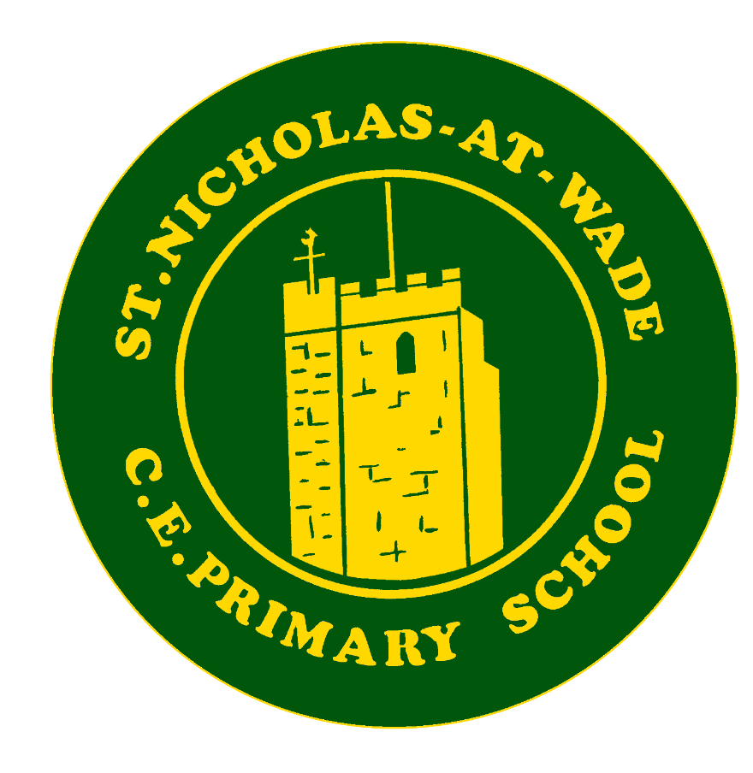
Curriculum – English
Knowledge and Skills

Knowledge and Skills progression in ENGLISH Year group overview

Features
At key stage 1, the knowledge progression takes full account of the national curriculum’s strands of: Speech and language, reading, writing and spelling, vocabulary, grammar & punctuation

At key stage 2, the knowledge progression takes full account of the national curriculum’s strands of: Speech and language, reading, writing and spelling, vocabulary, grammar & punctuation

Skills are dependent on specific knowledge. A skill is the capacity to perform and in order to perform a deep body of knowledge needs to be acquired and retained.
The working scientifically part does not conform with the knowledge-rich system as it is checking on pupils’ ability to, amongst other things, carry out research, ask questions and carry out tests. The working scientifically statements should be assessed as an on-going feature of the science lessons, whilst the scientific knowledge should be assessed away from the point of teaching.

St Nicholas ENGLISH Experience
In addition to the National Curriculum knowledge and skills, at St.Nicholas at Wade Primary School, we want to enrich the curriculum with additional experiences within our locality. These additional experiences will include:
- Making regular use of the school library weekly, including teacher-led activities within this time.
- Regular support and updates from the student cohort - Reading Influencers.
- Visits from authors, poets, illustrators, publishers or book shops
- Taking part in World Book day
- Taking part in termly Reading Challenges to encourage participation during holiday times.
- Participation in regular opportunities/competitions in writing narratives and poetry.
- Participation in a reward scheme to encourage participation in reading.
- Online reading log to encourage the home/school relationship and to promote engagement of reading by and within the family.

Knowledge and Skills Progression in English – Reception Development Matters Statements
WRITING

- Develop their small motor skills so that they can use a range of tools competently, safely and confidently. Suggested tools: pencils for drawing and writing, paintbrushes, scissors, knives, forks and spoons. (PD)
- Develop the foundations of a handwriting style which is fast, accurate and efficient. (PD)
- Form lower-case and capital letters correctly. (L)
- Spell words by identifying the sounds and then writing the sound with letter/s. (L)
- Write short sentences with words with known letter-sound correspondences using a capital letter and full stop. (L)
- Re-read what they have written to check that it makes sense. (L)
- Use their core muscle strength to achieve a good posture when sitting at a table or sitting on the floor. (PD)

READING
- Read individual letters by saying the sounds for them. (L)
- Blend sounds into words, so that they can read short words made up of known letter-sound correspondences. (L)
- Read some letter groups that each represent one sound and say sounds for them. (L)
- Read a few common exception words matched to the school’s phonic programme. (L)
- Read simple phrases and sentences made up of words with known letter–sound correspondences and, where necessary, a few exception words. (L)
- Re-read these books to build up their confidence in word reading, their fluency and their understanding and enjoyment. (L)

PHONICS
- Read individual letters by saying the sounds for them. (L)
- Blend sounds into words, so that they can read short words made up of known letter-sound correspondences. (L)
- Read some letter groups that each represent one sound and say sounds for them. (L)
- Read a few common exception words matched to the school’s phonic programme. (L)
- Read simple phrases and sentences made up of words with known letter–sound correspondences and, where necessary, a few exception words. (L)

Early Learning Goals feeding into National Curriculum - English
WRITING

- Hold a pencil effectively in preparation for fluent writing – using the tripod grip in almost all cases. (PD)
- Write recognisable letters, most of which are correctly formed. (L)
- Spell words by identifying sounds in them and representing the sounds with a letter or letters. (L)
- Write simple phrases and sentences that can be read by others. (L)

READING
- Demonstrate understanding of what has been read to them by retelling stories and narratives using their own words and recently introduced vocabulary. (L)
- Anticipate (where appropriate) key events in stories. (L)
- Use and understand recently introduced vocabulary during discussions about stories, nonfiction, rhymes and poems and during role play. (L)
- Make use of props and materials when role playing characters in narratives and stories. (EAD)
- Invent, adapt and recount narratives and stories with peers and their teacher. (EAD)
- Listen attentively and respond to what they hear with relevant questions, comments and actions when being read to and during whole class discussions and small group interactions. (CAL)
- Make comments about what they have heard and ask questions to clarify their understanding. (CAL)
- Hold conversation when engaged in back-and-forth exchanges with their teacher and peers. (CAL)
- Participate in small group, class and one-to-one discussions, offering their own ideas, using recently introduced vocabulary. (CAL)
- Offer explanations for why things might happen, making use of recently introduced vocabulary from stories, non-fiction, rhymes and poems when appropriate. (CAL)
- Express their ideas and feelings about their experiences using full sentences, including use of past, present and future tenses and making use of conjunctions, with modelling and support from their teacher. (CAL)

PHONICS
- Say a sound for each letter in the alphabet and at least 10 digraphs. (L)
- Read words consistent with their phonic knowledge by sound-blending. (L)
- Read aloud simple sentences and books that are consistent with their phonic knowledge, including some common exception words. (L)

Key Vocabulary

National Curriculum Subject Content
READING - Skills Progression
Word Reading /Decoding | Year 1 | Year 2 | Year 3 | Year 4 | Year 5 | Year 6
Word Reading /Decoding | Children learn to:  •apply phonic knowledge and skills as the route to decode words.  •respond speedily with the correct sound to graphemes (letters or groups of letters) for all 40+ phonemes, including, where applicable, alternative sounds for graphemes  •read accurately by blending sounds in unfamiliar words containing GPCs that have been taught  •read common exception words, noting unusual correspondences between spelling and sound and where these occur in the word  •read words containing taught GPCs and –s, –es, –ing, –ed, –er and –est endings  •read other words of more than one syllable that contain taught GPCs  •read words with contractions [for example, I’m, I’ll, we’ll], and understand that the apostrophe represents the omitted letter(s)  •read books aloud, accurately, that are consistent with their developing phonic knowledge and that do not require them to use other strategies to work out words  •reread these books to build up their fluency and confidence in word reading | Children learn to:  •continue to apply phonic knowledge and skills as the route to decode words until automatic decoding has become embedded and reading is fluent  •read accurately by blending the sounds in words that contain the graphemes taught so far, especially recognising alternative sounds for graphemes  •read accurately words of two or more syllables that contain the same graphemes as above  •read words containing common suffixes  •read further common exception words, noting unusual correspondences between spelling and sound and where these occur in the word  •read most words quickly and accurately, without overt sounding and blending, when they have been frequently encountered  •read aloud books closely matched to their improving phonic knowledge, sounding out unfamiliar words accurately, automatically and without undue hesitation  •reread these books to build up their fluency and confidence in word reading | Children learn to:  •apply their growing knowledge of root words, prefixes and suffixes (etymology and morphology), both to read aloud and to understand the meaning of new words they meet  •read further exception words (Y3/4 list), noting the unusual correspondences between spelling and sound, and where these occur in the word  •children should be able to decode most new words outside their spoken vocabulary, making a good approximation of the pronunciation. | As for Y3, children learn to:  •apply their growing knowledge of root words, prefixes and suffixes (etymology and morphology), both to read aloud and to understand the meaning of new words they meet  •read a wide range of exception words (Y3/4 list and similar).  •as decoding becomes more secure, children should become independent, fluent and enthusiastic readers. | Children learn to:  • No direct teaching of word-reading skills is required for most children; they apply their growing knowledge of root words, prefixes and suffixes (morphology and etymology), both to read aloud and to understand the meaning of new words that they meet.  •children read some of the exception words (Y5/6 list and similar).  •attention is paid to new vocabulary, both its meaning and pronunciation. | As for Y5, children learn to:  • apply their growing knowledge of root words, prefixes and suffixes (morphology and etymology), both to read aloud and to understand the meaning of new words that they meet.  •children read a wide range of exception words, including the Y5/6 list and similar words which occur in the texts they read.
Comprehension | Children learn to:  •develop pleasure in reading, motivation to read, vocabulary and understanding by:  listening to and discussing a wide range of poems, stories and non-fiction at a level beyond that at which they can read independently  being encouraged to link what they read or hear to their own experiences  •becoming very familiar with key stories, fairy stories and traditional tales, retelling them and considering their particular characteristics  •recognising and joining in with predictable phrases  •learning to appreciate rhymes and poems, and to recite some by heart  •discussing word meanings, linking new meanings to those already known  •understand both the books they can already read accurately and fluently and those they listen to by:  -drawing on what they already know or on background information and vocabulary provided by the teacher;  - checking that the text makes sense to them as they read, and correcting inaccurate reading;  -discussing the significance of the title and events;  -making inferences on the basis of what is being said and done;  -predicting what might happen on the basis of what has been read so far  •participate in discussion about what is read to them, taking turns and listening to what others say  •explain clearly their understanding of what is read to them | Children learn to:  •develop pleasure in reading, motivation to read, vocabulary and understanding by:  -listening to, discussing and expressing views about a wide range of contemporary and classic poetry, stories and non-fiction at a level beyond that at which they can read independently;  -discussing the sequence of events in books and how items of information are related  becoming increasingly familiar with and retelling a wider range of stories, fairy stories and traditional tales  -being introduced to non-fiction books that are structured in different ways  -recognising simple recurring literary language in stories and poetry  -discussing and clarifying the meanings of words, linking new meanings to known vocabulary  discussing their favourite words and phrases  -continuing to build up a repertoire of poems learnt by heart, appreciating these and reciting some, with appropriate intonation to make the meaning clear  •understand both the books that they can already read accurately and fluently and those that they listen to by:  -drawing on what they already know or on background information and vocabulary provided by the teacher  checking that the text makes sense to them as they read, and correcting inaccurate reading  making inferences on the basis of what is being said and done  -answering and asking questions  -predicting what might happen on the basis of what has been read so far  •participate in discussion about books, poems and other works that are read to them and those that they can read for themselves, taking turns and listening to what others say  •explain and discuss their understanding of books, poems and other material, both those that they listen to and those that they read for themselves | Children learn to:  •develop positive attitudes to reading, and an understanding of what they read, by:  listening to and discussing a wide range of fiction, poetry, plays, non-fiction and reference books or textbooks  •reading books that are structured in different ways and reading for a range of purposes  •using dictionaries to check the meaning of words that they have read  •increasing their familiarity with a wide range of books, including fairy stories, myths and legends, and retelling some of these orally  •identifying themes and conventions in a wide range of books  •preparing poems and play scripts to read aloud and to perform, showing understanding through intonation, tone, volume and action  •discussing words and phrases that capture the reader’s interest and imagination  •recognising some different forms of poetry [for example, free verse, narrative poetry]  •understand what they read, in books they can read independently, by:  checking that the text makes sense to them, discussing their understanding, and explaining the meaning of words in context  •asking questions to improve their understanding of a text  •drawing inferences such as inferring characters’ feelings, thoughts and motives from their actions, and justifying inferences with evidence  •predicting what might happen from details stated and implied  •identifying main ideas drawn from more than 1 paragraph and summarising these  •identifying how language, structure, and presentation contribute to meaning  •retrieve and record information from non-fiction  •participate in discussion about both books that are read to them and those they can read for themselves, taking turns and listening to what others say | Children learn to:  •with growing confidence, and reading from a wider range of texts children develop positive attitudes to reading, and an understanding of what they read, by listening to and discussing a wide range of fiction, poetry, plays, non-fiction and reference books or textbooks  •reading books that are structured in different ways and reading for a range of purposes  •using dictionaries to check the meaning of words that they have read  •increasing their familiarity with a wide range of books, including fairy stories, myths and legends, and retelling some of these orally  •identifying themes and conventions in a wide range of books  •preparing poems and play scripts to read aloud and to perform, showing understanding through intonation, tone, volume and action  •discussing words and phrases that capture the reader’s interest and imagination  •recognising some different forms of poetry [for example, free verse, narrative poetry]  •understand what they read, in books they can read independently, by:  •checking that the text makes sense to them, discussing their understanding, and explaining the meaning of words in context  •asking questions to improve their understanding of a text  •drawing inferences such as inferring characters’ feelings, thoughts and motives from their actions, and justifying inferences with evidence  •predicting what might happen from details stated and implied  •identifying main ideas drawn from more than 1 paragraph and summarising these  •identifying how language, structure, and presentation contribute to meaning  •retrieve and record information from non-fiction  •participate in discussion about both books that are read to them and those they can read for themselves, taking turns and listening to what others say. | Children learn to:  •maintain positive attitudes to reading and an understanding of what they read by:  continuing to read and discuss an increasingly wide range of fiction, poetry, plays, non-fiction and reference books or textbooks  •reading books that are structured in different ways and reading for a range of purposes  increasing their familiarity with a wide range of books, including myths, legends and traditional stories, modern fiction, fiction from our literary heritage, and books from other cultures and traditions  •recommending books that they have read to their peers, giving reasons for their choices  identifying and discussing themes and conventions in and across a wide range of writing  •making comparisons within and across books  •learning a wider range of poetry by heart  •preparing poems and plays to read aloud and to perform, showing understanding through intonation, tone and volume so that the meaning is clear to an audience  •understand what they read by:  checking that the book makes sense to them, discussing their understanding and exploring the meaning of words in context  •asking questions to improve their understanding  •drawing inferences such as inferring characters’ feelings, thoughts and motives from their actions, and justifying inferences with evidence  •predicting what might happen from details stated and implied  •summarising the main ideas drawn from more than 1 paragraph, identifying key details that support the main ideas  •identifying how language, structure and presentation contribute to meaning  •discuss and evaluate how authors use language, including figurative language, eg. metaphor, personification, considering the impact on the reader  •distinguish between statements of fact and opinion  retrieve, record and present information from non-fiction  •participate in discussions about books that are read to them and those they can read for themselves, building on their own and others’ ideas and challenging views courteously  •explain and discuss their understanding of what they have read, including through formal presentations and debates, maintaining a focus on the topic and using notes where necessary  •provide reasoned justifications for their views | Children learn to:  •with confidence and familiarity children participate in discussion about books that are read to them and those they read independently  •continuing to read and discuss an increasingly complex range of fiction, poetry, plays, non-fiction and reference books or textbooks  •reading books that are structured in different ways and reading for a range of purposes  increasing their familiarity with a wide range of books, including myths, legends and traditional stories, modern fiction, fiction from our literary heritage, and books from other cultures and traditions  •recommending books that they have read to their peers, giving reasons for their choices  identifying and discussing themes and conventions in and across a wide range of writing  •making comparisons within and across books  •learning a wider range of poetry by heart  •preparing poems and plays to read aloud and to perform, showing understanding through intonation, tone and volume so that the meaning is clear to an audience  •understand what they read by:  checking that the book makes sense to them, discussing their understanding and exploring the meaning of words in context  •asking questions to improve their understanding  •drawing inferences such as inferring characters’ feelings, thoughts and motives from their actions, and justifying inferences with evidence  •predicting what might happen from details stated and implied  •summarising the main ideas drawn from more than 1 paragraph, identifying key details that support the main ideas  •identifying how language, structure and presentation contribute to meaning  •discuss and evaluate how authors use language, including figurative language, eg. metaphor, personification, considering the impact on the reader  •distinguish between statements of fact and opinion  retrieve, record and present information from non-fiction  •participate in discussions about books that are read to them and those they can read for themselves, building on their own and others’ ideas and challenging views courteously  •explain and discuss their understanding of what they have read, including through formal presentations and debates, maintaining a focus on the topic and using notes where necessary  •provide reasoned justifications for their views

