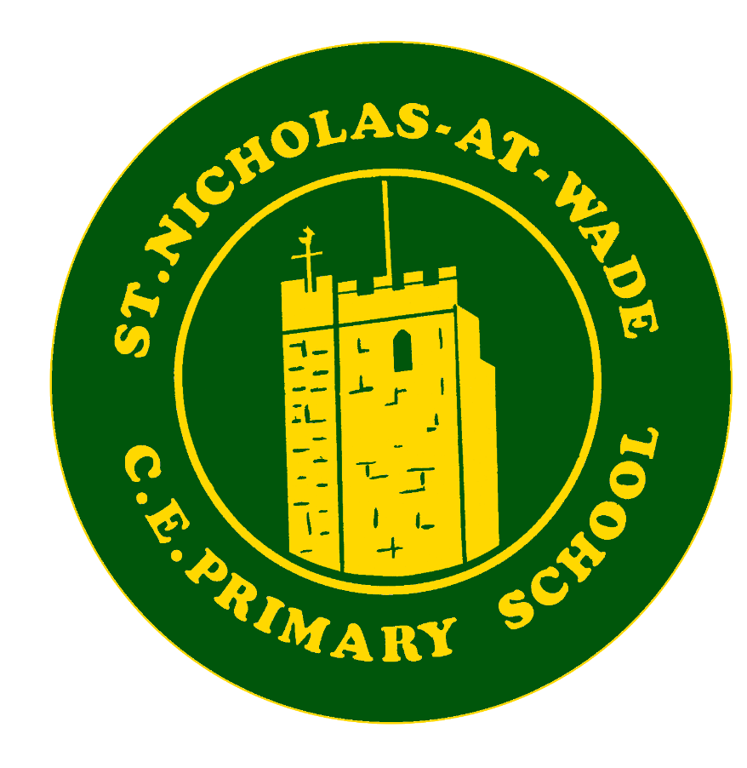

Curriculum – PSHE Policy
Intent ♦ Implementation ♦ Impact
Intent
At St. Nicholas-at-Wade Primary School, we believe that all pupils deserve a fully rounded curriculum to become confident, independent, lifelong learners. Our curriculum intent is centred around the following aims, which are fully embedded across all subjects:
- Every child a reader.
- Every child a learner
- Every child a citizen
- Every child happy and healthy
- Every child creative and curious.

This policy, having considered the schools context and safeguarding, sets out the school’s aims, principles and strategies in relation to the teaching of PSHE and citizenship.

‘The wise builder, builds their house on the rock’
We want to give our children something solid to stand on, foundations that will allow them build a future for themselves and others that will be grounded in their own personal character, beliefs and values.
At St Nicholas at Wade, we see personal development as a primary aim for educators and know that a school’s contribution to a child’s life goes hand in hand with academic development. We also involve our parents in this, as the most important influence on their child’s life, so that we work together to ensure our children have the qualities and character they need to flourish in society.

We want our children to leave St Nicholas as honest, courageous, resilient and kind individuals who:
• Can take personal responsibility, so that they are able to control their own actions and responses
• Can build and maintain healthy relationships,
• Can bounce back from setbacks, knowing when to ask for help or when to try a different approach
• Understand the link between physical health and well-being and exercise their body and know how to fuel it with good food
• Respects and values difference and similarity
• Is prepared for modern Britain
• Are courageous for themselves and prepared to be courageous for those who may not have a voice
• Shows kindness and gratitude
• Feels belonging and is prepared to work for the greater good
• Knows that hard work is worth it
• Are Happy

Courage, Resilience, Honesty, Kindness, Be the best you can be…It’s who we are! St Nicholas at Wade CEP School
Implementation
Aristotle’s Nicomachean Ethics:
‘Our actions become our habits, our habits become our character, our character is who we are’
This quote summarises the implementation approach that we take here at St Nicholas. We are relentless in developing personal character.
At St Nicholas at Wade we will do this through:
- Our Christian values and the ‘St Nicholas Way’
- Our behaviour strategy
- The PSHE and RSE Curriculum
- Religious Education
- Worship and assemblies
- The teaching of British Values
- Pupil voice
- The Junior leadership team, head pupils and other positions of responsibility
- Curriculum enrichment opportunities and extra-curricular provision for example anti bullying week
The teaching of this is not only taught explicitly but is interwoven through the curriculum, it is in every exchange between pupils and teachers and in every action that is taken.
EYFS - In the Foundation Stage, PSHE and citizenship is taught as an integral part of topic work and is embedded throughout the curriculum. The objectives taught are the Personal, Social and Emotional Development statements from ‘Development Matters in the EYFS’ and the PSED Early Learning Goals.
EYFS, Key Stage 1 and Key Stage 2 Discrete PSHE is taught through a clear and comprehensive scheme of work (Heartsmart) in line with the National Curriculum. We have enriched this programme by including values based learning to ensure that our vision is realised and our children have everything they need for their next steps into their next school, their next friendships and into their future.
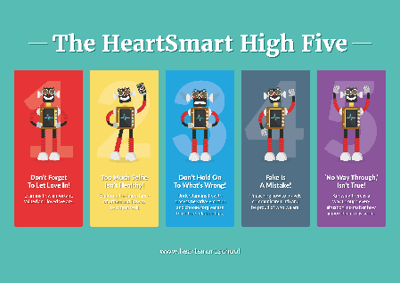
PSHE is taught through HeartSmart and bespoke unit ‘The St Nicholas Way’ each year group studying the same unit at the same time (at their own level):
Autumn 1: The St Nicholas Way
Autumn 2: Don’t Forget to let Love in
Spring 1: Too much selfie isn’t Healthy
Spring 2: Don’t Rub it in – Rub it Out
Summer 1: Fake is a Mistake
Summer 2: No Way Through, isn’t True
All children have explicit weekly PSHE lessons and there are no interventions during PSHE
However, personal development is implicit in every interaction, lesson and decision taken in school.
Impact
Our children are able to:
• Take personal responsibility, so that they are able to control their own actions and responses
• Build and maintain healthy relationships,
• Be resilient
• Know how to keep their mind and body healthy
• Respect and value difference and similarity
• Be open minded, respectful, socially and morally responsible, active members of society in modern Britain
• Be courageous for themselves and prepared to be courageous for those who may not have a voice
• Show kindness and gratitude
• Belong and be prepared to work for the greater good
• Work hard
• Find joy and be kind

It is important to measure that the work we are doing in this subject is having an impact. We measure this through the following:
- All learning is recorded through the ‘Class big Book’ this is monitored by the PSHE leader each seasonal term and teachers receive feedback
- Children evaluate their own learning in Heartsmart at the end of each unit, this is recorded over time and helps teachers to build a picture of children’s strengths and areas of difficulty
- Children who need support, access pastoral interventions
- Pupil conferencing 2 x per year gives leaders insight into the universal strengths of both the direct and indirect teaching and learning of PSHE
- Governors monitor the provision of PSHE and Safeguarding to strengthen our monitoring of this subject

