Term 1 Topic - Enchanted Woodland
Due - Friday 14th October
To evidence your homework please feel free to draw, write or use photos of any creations or activities you complete, in order to show us what you’ve learnt and researched at home. Choose one or as many activities as you would like
Writing | Maths
This term we will be reading Eric Carle’s - Brown Bear, Brown Bear, What do you see?  Choose a special place and have a good hunt around. You may choose the beach, your garden, a woodland or even your bedroom. What do you see?  Write simple sentences beginning with...  I can see ...  Don’t forget your capital letter, full stop and finger spaces. You may prefer to draw a picture of your chosen place and label it. | Sorting objects - can you choose a range of objects and group them into different groups? Take a photo and explain how you sorted them e.g. by size, by colour, by number.  Counting - Read and write numbers 0 to 10. Can you draw a picture to represent this number? Can you order them from smallest to greatest and greatest to smallest?
Science | Science
Plant some wild or common flowers. Keep a record of the observations you make throughout the term.  Can you find out some interesting facts about the seed or bulb you have planted?  Can you write 3 top tips of how to look after a plant to keep it healthy and strong? | Just like people live in different types of homes so do animals. Research where a range of woodland animals live and draw their home. Do you notice any similarities of differences? Why do you think they may live underground or high up in a tree?
Design Technology | Art
Visit a local woodland and go on a scavenger hunt to collect natural objects such as twigs, pebbles, bark and leaves. Then design a miniature home or garden for fairies and pixies to visit. Once you’ve drawn and labelled your design, get building!  What features might you include?  What’s the best way to use each of the objects?  When you’ve completed your miniature home, think about the following questions:  What was your favourite part?  Is there anything you would change?  Did you find anything tricky? | 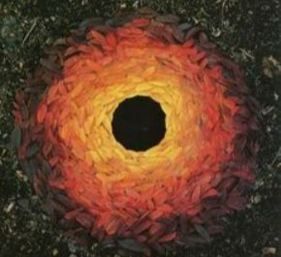  Using a range of natural materials to create your own transient Art. You may want to explore the wonderful Artwork by Andy Goldsworthy to give you inspiration.

