Term 2 Topic - Splendid Skies
Due - Friday 9th December
To evidence your homework please feel free to draw, write or use photos of any creations or activities you complete, in order to show us what you’ve learnt and researched at home. Choose one or as many activities as you would like
Writing | Maths
Research different weather poems. What do you like about them? Do they rhyme? Is it an acrostic poem?  Now choose a type of weather and write your own poem. Draw some exciting pictures to match the weather you have chosen. | Learn the number bonds to 10. How many different ways can you make 10? Write the number sentences to show each way you found.  Please see a range of activities on our class page that are linked to our learning this term.
Science | Geography
Find out about the 4 seasons. Which months are in each season? What is the weather like in each season?  Draw yourself and what you wear in Summer, Spring, Autumn and Winter. Can you label what you are wearing? Do you have a favourite season? | Is the weather the same across the whole world?  Research an extreme type of weather e.g. tsunamis, hurricanes, a drought or blizzards. Where does this weather occur? Why? How does it affect people?
Design Technology | History
Let’s go fly a kite! You may want to watch Mary Poppins to inspire this activity. Design and create a kite. Which materials will you use? How will you make it sturdy and stiff? After designing your kite, make it and test it! Take photos to show what happened. | Research different types of planes. Can you sketch and label the plane? When was the plane used? What was it used for?  Can you compare old planes to modern day planes? How have they changed?
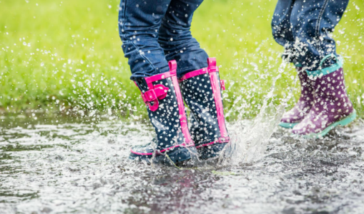
This is also the perfect time to go and explore all different types of weather. You may want to get your wellington boots on and jump in puddles! Wrap up warm if it’s a windy day! Take some photos of the different weather you experience; which was your favourite and why?

