Special educational needs (SEN) report 2021-22

- Contact details:
Inclusion Leader: Sarah Kent
Sarah.kent@st-nicholas-birchington.kent.sch.uk
01843 847253
SEN Governor: Poppy Montgomery

- Number and % of pupils with EHC Plans and number and % with SEN Support
School -21 pupils (11%) in total SEN Support & EHC plan
14 SEN support
7 pupils EHC plans (+ 4 applications)

- Number and % of pupils with SEN (all) with each type of need.
(NB This is not separated into year groups due to identification of children)
Number of Need Type (% of SEN)
Physical and Sensory 0 (0%)
Communication and Interaction 14 (67%)
Cognition and Learning 5 (24%)
Social Emotional and Mental Health 2 (10%)

- Funding provided to the school for SEN – this is the SEN Notional Fund and any High Needs Funding
High needs funding/ Notional Funding: 2021-22 (June 2021-June 2022) £58,704.77
We received Higher needs funding for 8 children.

- The outcomes achieved by last leaving group of pupils with SEN (2021 leavers) N.B, End Spring 2. Teacher assessment. % at age related.
SEN | EYFS  1 pupil | KS1  2 pupils | KS2  5 pupils
Reading | 0 % | 0% | 40% of SEN cohort
Writing | 0% | 0% | 40% of SEN cohort
SPAG |  |  | 40% of SEN cohort
Maths | 0% | 0% | 60% of SEN cohort
Combined | 0% | 0% | 40%

Progress for all SEN: Autumn 1 – Summer 2 2022
(N.B 3 steps = expected progress)
NB: No Year R in this data
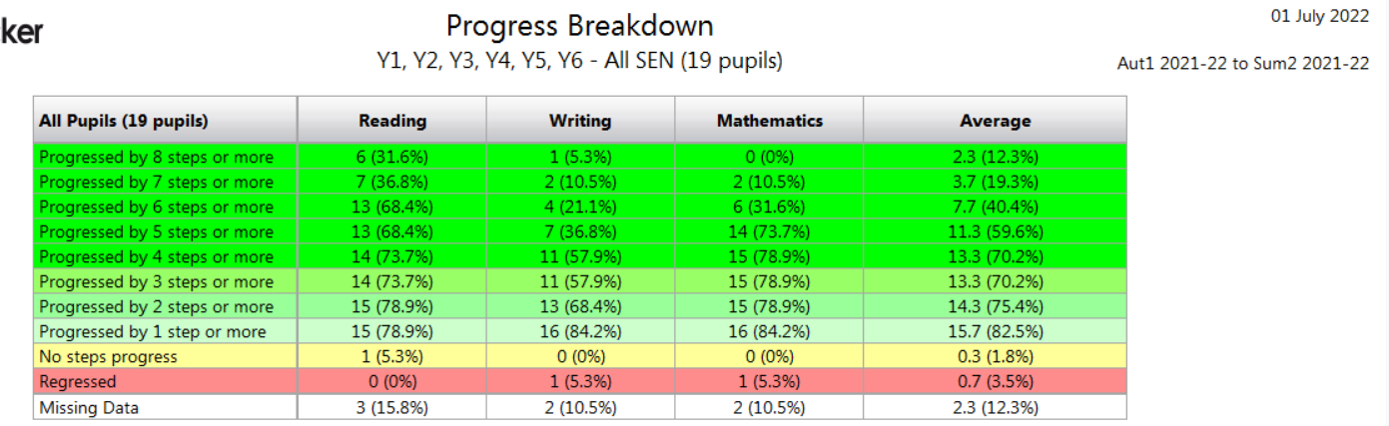
Attainment for all SEN Summer 2 2022
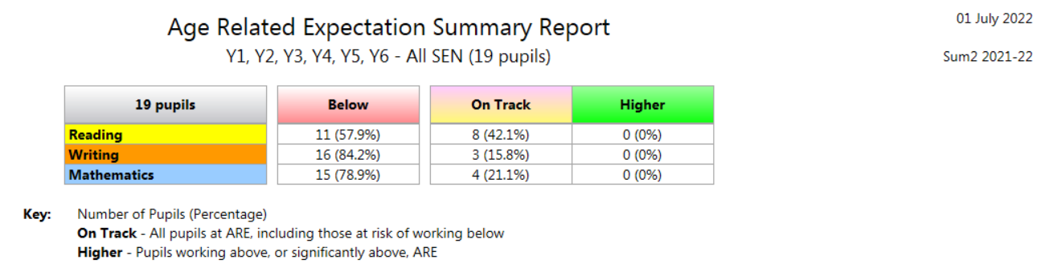

Attendance of pupils with SEN
 | % sessions missed due to overall absence | % persistent absentees – absent 15% or more sessions
 | School | School
No SEN | 7.1 | 19.4
SEN support | 10.1 | 37.5
SEN with statement or EHCP | 15.4 | 42.9

- Exclusions occurring in the last 12 months. Number fixed term incidents (% pupils with SEN / % pupils with no SEN).
2 fixed term exclusion (1 child) (0% no SEN 100% SEN)

- Number permanent exclusions (% pupils with SEN / % pupils with no SEN)
O

- (Secondary) Destinations of pupils with SEN.
All of our current Year 6 cohort are transferring to mainstream secondary schools. 1 parent is appealing for Specialist Provision.

- Result of last satisfaction survey of parents of pupils with SEN
Currently gathering information
- Staff Training

2019-2020 Training
ADHD awareness October 2019 / July 2020  Autism in girls September 2019  Selective Mutism October 2019  ‘Pupil Anxiety and Mental Health’2.10.19  ‘Staff Wellbeing and Sleep Hygiene’27.11.19  SEND and learning difficulties November 2019  Stammering awareness March 2020  AEN update seasonally  SENCo Forum termly | Training to Support an individual child / children  Training to Support an individual child / children  Training to Support an individual child / children  Teacher training to support QFT of SEND  Training to support staff wellbeing  Training to support QFT  Training to Support an individual child / children  SENCo update  SENCo training / support
2020-2021
October 2020  Alternative methods of communication  SENCo update X 6 – SENCo attended  Providing Context For MSCS  SEND and learning behaviour training  Adverse childhood experiences | 3 members of staff linked to key child
2021-22
2021-22  SENCo update X 6 – SENCo attended  Family THRIVE  Wellbeing Buddy Training  How to develop parent / carer engagement  Foundation to Drawing and Talking  Anxiety based school avoidance  Meta cognition  Techniques to visually support learners | Training to support an individual child / children  Training to support an individual child / children  Professional development  Training to support an individual child / children  Training to support an individual child / children  Training to support an individual child / children  Training to support an individual child / children

- Actions that will be included in the next school development plan to improve provision further for pupils with SEN
- Improving writing outcomes for pupils with SEN
- Improving maths outcomes for pupils with SEN
- Improving attendance for pupils with SEN
- Celebrating and Promoting diversity

Available as a separate document.

